**Cloud Computing**

**6331**

Programming Assignment 7

Thursday, May 14, 2015

Harish Kumar Chikkamaranahalli Ashokkumar

10011005959

**Contents:**

Requirement: 3

Steps taken for setting up EBS (Elastic Beans Stalk): 3

Configuration done at EBS: 3

Technical Details of the website hosted on EBS: 5

References: 5

# Requirement:

The requirement was to set up a web service, that allow a user to authenticate (user name, password) and then select (local) pictures that are transferred to the cloud service.

Users may either upload picture (they must be less than 20KB) or view all pictures.

You must make your service scalable – that is, you should spawn new instances to handle busy traffic, and kill (exit) instances when not busy.

# Steps taken for setting up EBS (Elastic Beans Stalk):

The below steps give you a brief knowledge on setting up your EBS for auto scaling.

1. Select all the scripts as well as AWS autoloader scripts required for AWS connections and create a zip file.

2. Create an IAM user and create an IAM group, assign Administrator Access and Amazon App Stream Full Access to the group. Assign the user to the group created. 3. Create a new application in Elastic Bean Stalk, select create webserver, and make the necessary selections also select the zip file created earlier and deploy the project.

4. The web service can be accessed with the link provided in EBS after deploying of project.

5. To monitor the scalability and load balancing we can set triggers to launch new instances to handle the load, this can be done in the configuration part of EBS.

6. The Scaling Trigger is set to the values as specified earlier.

7. Send requests to web service the count of requests being more than the threshold set to trigger a new instance. Verify the same in EC2 console is a new Instance is created.

# Configuration done at EBS:

* Environment type:

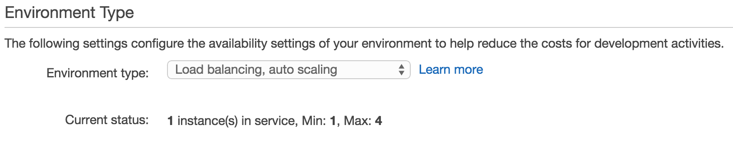

* Auto Scaling:

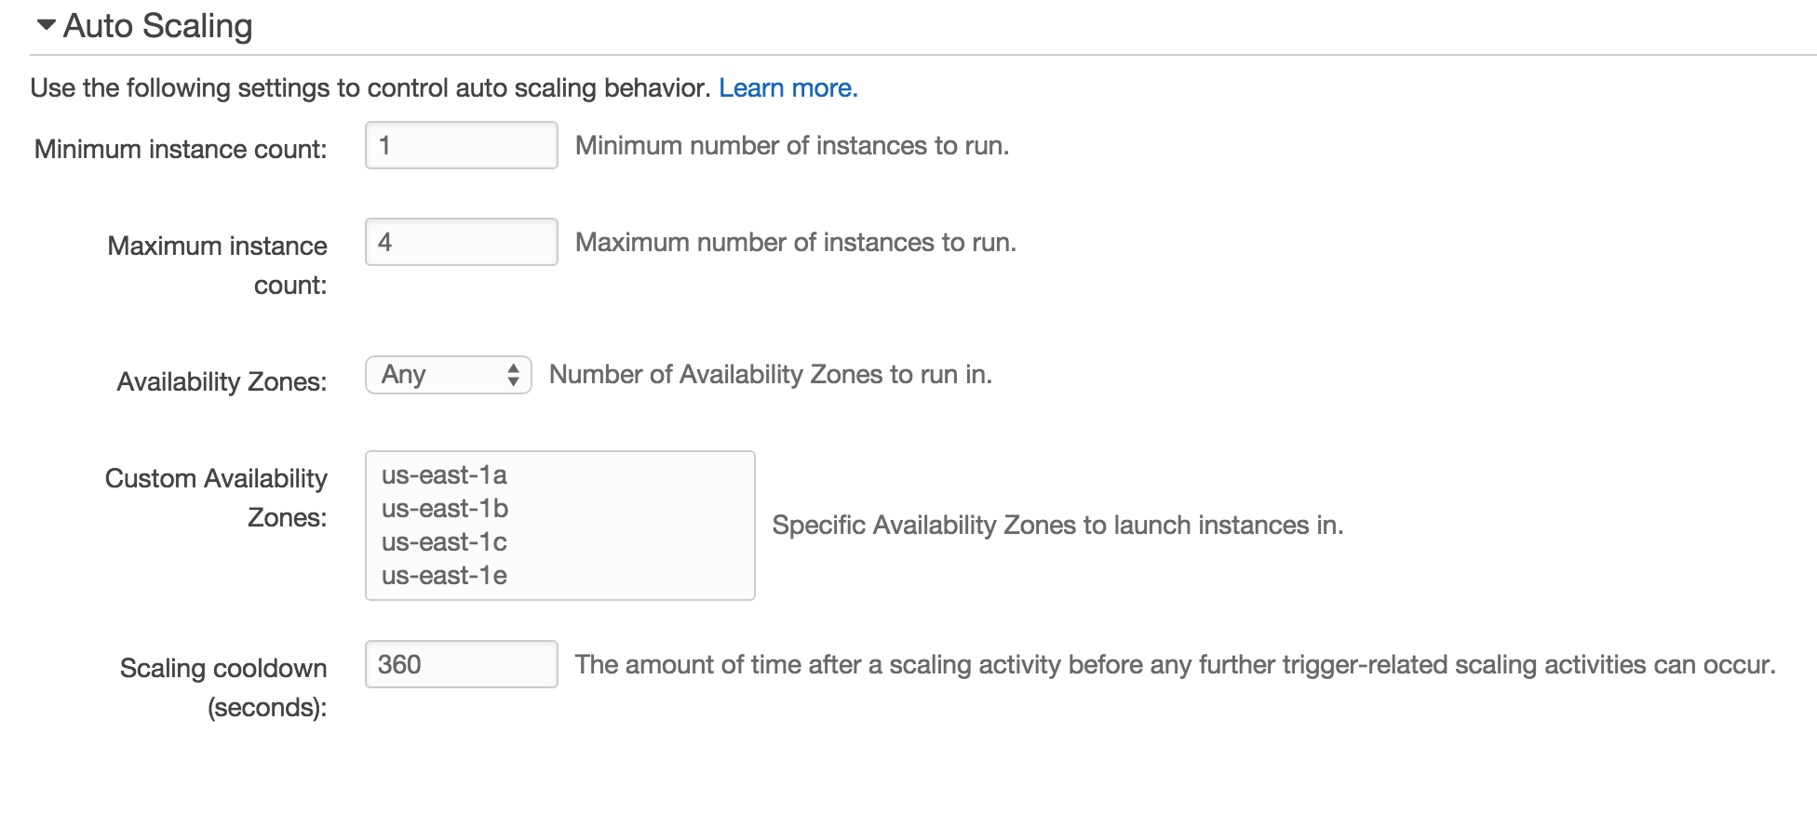

* Scaling Trigger:

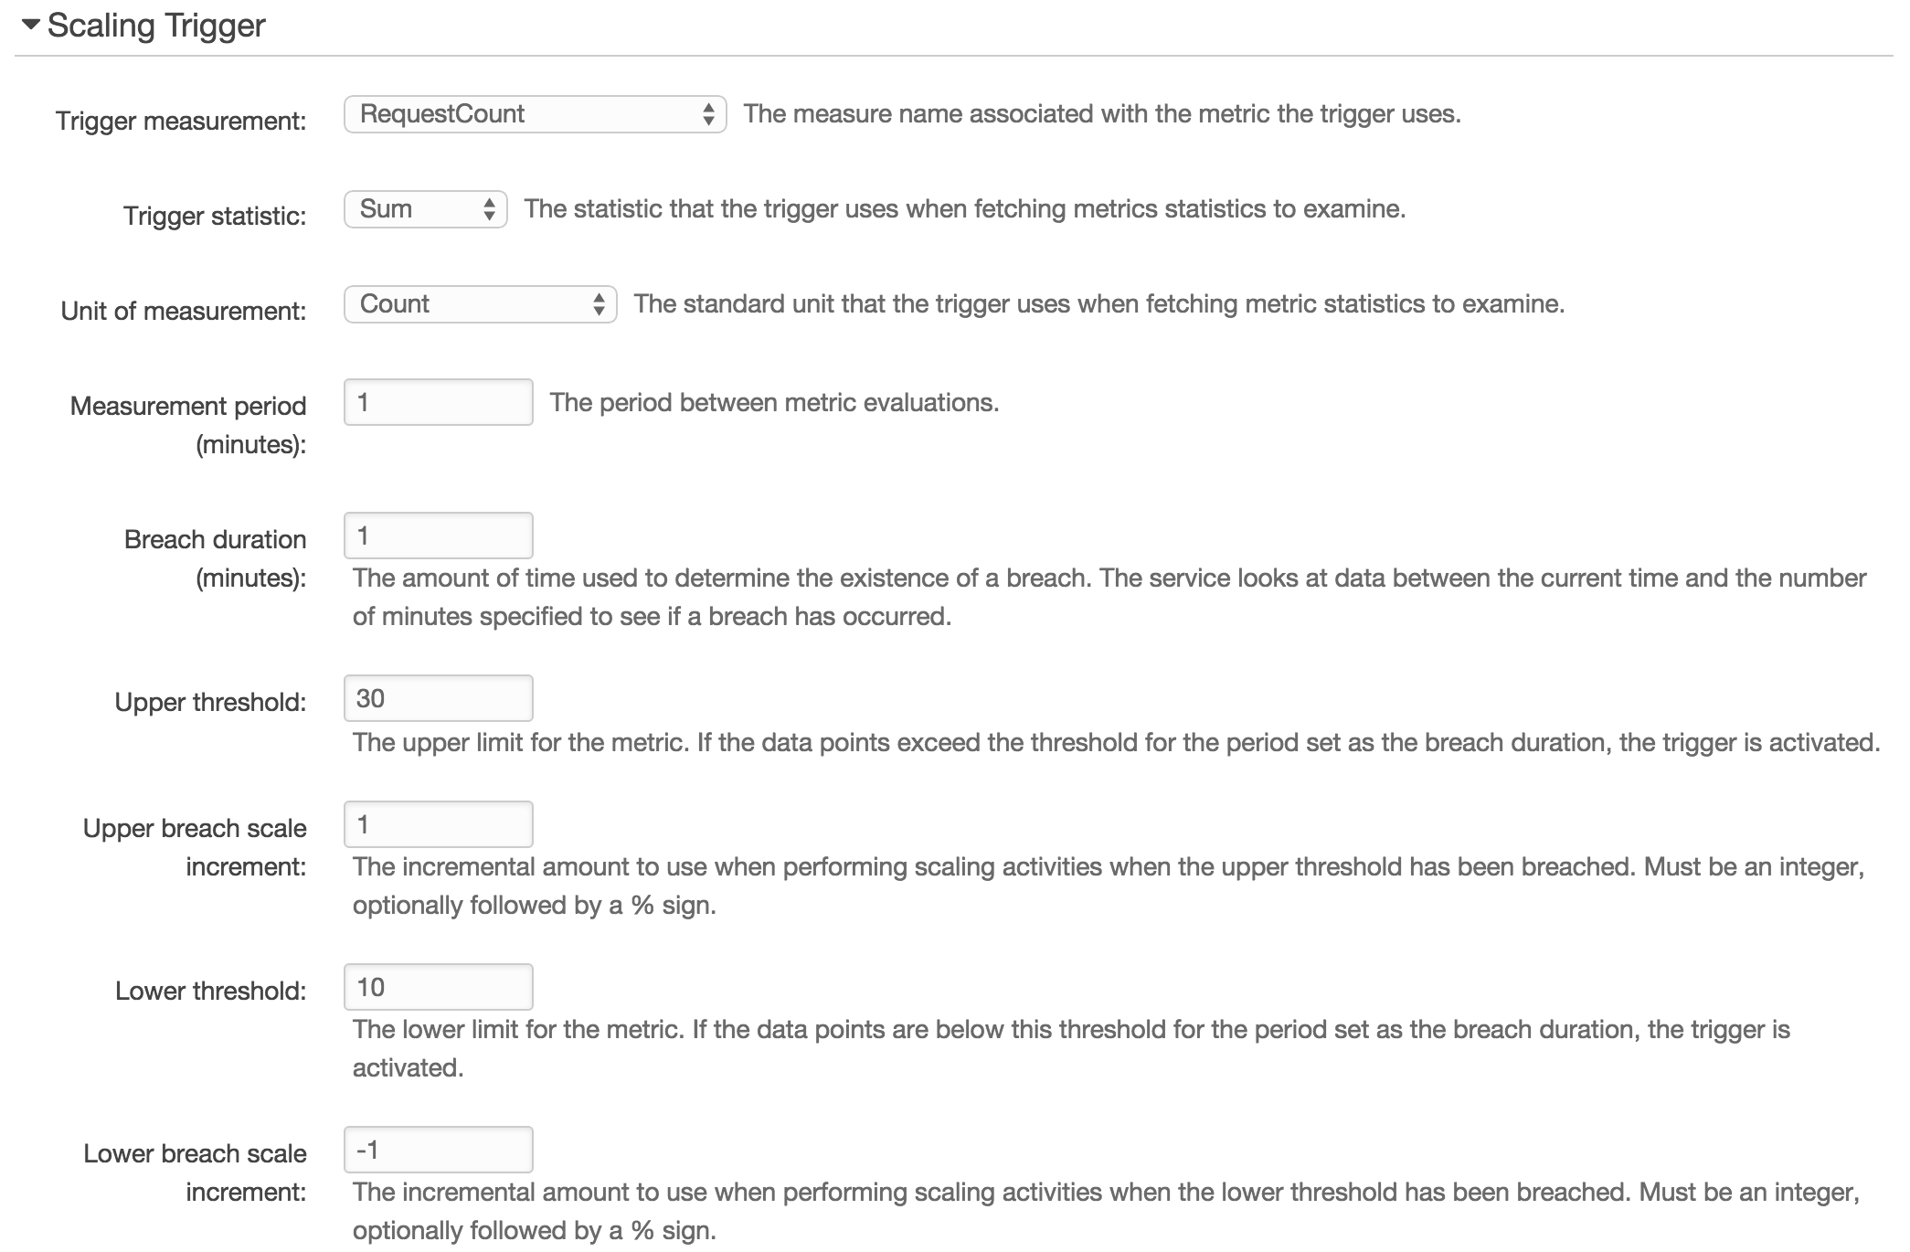

# Technical Details of the website hosted on EBS:

The project that has been hosted on EBS uses RDS service of amazon to store the user details and image details that is uploaded. It also uses S3 service of amazon to store the images and only those, which are lesser than 20kb. I have used PHP to develop the website.

# References:

* <http://aws.amazon.com/ebs/faqs/>
* <http://php.net/manual/en/intro-whatis.php>